Automating Development Control Regulations (AutoDCR)
&
Drawing the Architectural plan in drawing format as per AutoDCR Software requirements ( PreDCR )

SMC PreDCR User Manual


Document revision: 1
Date of issue: 18/02/2009

© SoftTech Engineers Pvt. Ltd.
The Pentagon, 5-A, 5th Floor,
Next to Pune - Satara Road Telephone Exchange,
Pune - 411 038, India
Phone: +91-20-24217676/8747 Fax: +91-20-24218747
www.softtech-engr.com
Email ID: support_dcr@softtech-engr.com

Table of Contents
Introduction……………………………………………………………………………………...3
Installation and Registration………………………...…………………………………4
running PreDCR…………………..……………………………………………………………...5
CREATE A NEW PROJECT………………………………………………………………………….6

PREDCR LAYERS INFORMATION……………………………………………………….7
Commands………………………………………………………………………………………..….13
Examples…………………………………………………………………………………………….21
Tools………………………………………………………………………………………………… 55
Introduction

PreDCR is a software application used to create the architectural plan as per AutoDCR software requirements. It works under AutoCAD environment with additional menu & toolbar.
Using PreDCR commands user can create all the required layers in one click. Once all the layers are created in the drawing user can use AutoCAD commands to draw layout plan.
As per AutoDCR requirement all building items like proposed plot, proposed work should be drawn on the corresponding layers. Short commands are provided to activate any layer in PreDCR
At any time user can verify if the drawn entities are properly closed or not, if proper name text
has been written inside all closed poly or not etc. PreDCR will highlight all the failed entities if any.
PreDCR can be used to modify/make and verify the existing or new architectural plan as per AutoDCR software requirements. Users are free to use AutoCAD commands and or PreDCR commands to achieve the main purpose which is:
Drawing the architectural plan in DWG format as per AutoDCR software requirements.
For Automating the process of Development Control Regulations user/draughtsman/architect have to follow some specifications. The following are the list of specifications that the user should follow.
- Plot layout, detailed floor plan and building section for all the floors should be there in one AutoCAD drawing file.
- All building items like proposed plot, proposed work, proposed parking etc must be drawn using closed polyline.
(i.e. Every entity must be closed LWPOLYLINE except Railway Line , Drain line, Water Line, Electric Line, DeadWall and Ground lvl.).
- Building Sub-Items must be exactly inside of outer closed polygon as per their place in architectural plan.
This means none of the edge or vertex of inside entity should be drawn outside its container entity.
For example Parking or Open Space poly must be exactly inside the plot Boundary poly.
Tools are provided in PreDCR to verify this check.
- Every Building Sub-Items should be given a specific/unique name (Text or MText entity) on the same layer & inside the entity poly. If name not found then AutoDCR will generate the name automatically. Naming Conventions should be followed properly.
e.g. Each Room should be given the concerned name Using <Assign Name> function of preDCR Living, Kitchen, Bedroom..Etc.
- Floor Name: GROUND FLOOR; TYPICAL FLOOR 1,2 & 5-8; TERRACE FLOOR
- Floor Items: Room Names should be given properly without using abbreviations so the software can identify perfect entity. This can be done by Assign name facility provided by the software.
- User shall use only following kind of entities for Building Items :-
LWPOLYLINE / TEXT / MTEXT
- If in a plan two proposed work are mirrored in that case user should provide two separate building plan for each proposed work.

Installation and Registration

System Requirements
• Pentium IV or better (or compatible processor)
• 256 MB RAM (128 MB minimum)
• Windows 98/2000/XP
• CD-ROM drive
• AutoCAD 2000 and onwards
Installation
To install PreDCR software on your computer please follow the given steps.
Step 1: Insert the supplied PreDCR CD in CD drive of the computer. Or download installer from NMC website.
Step 2: Run the PreDCR installer by double clicking on file "PreDCR_Installer.exe"
in the PreDCR CD/Pendrive.
Step 3: Follow the next steps in installer wizard to complete installation.
After successful installation, a PreDCR shortcut will be placed on your computer desktop as
shown below.
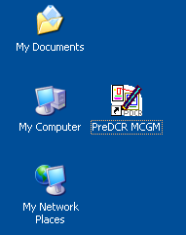
Figure 1: PreDCR shortcut on desktop

Running PreDCR
To run PreDCR software follows the given steps.
Step 1: Double click or right click on PreDCR icon and select open menu.
In Fig 1.You can also run it from Start-->Programs-->SEPL->PreDCR
Step 2: PreDCR will start under AutoCAD-2000 & onward versions.
Step 3: Select any AutoCAD version which is present in ur machine.
Note: If any Query regarding installation then just contact to following no’s as well as Email address
email address support_dcr@softTech-engr.com or contact
SoftTech Engineers Pvt. Ltd. on Phone : 2421-7676 / 2421-8747
Note: From next time PreDCR will start directly until you format your computer.
If user format their machine then they have reinstall PreDCR software

Create a New Project:
After you open PreDCR, you will find PreDCR Tool bar as shown in fig below..

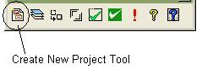

1. Use Create New Project Tool from PreDCR Toolbar to create a new project for the particular drawing.

2. One Project Information dialog will appear.

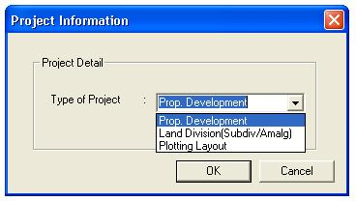

3. Select the Type of Project as per your proposal type.

3.1) If Project having only single plot & user have to take a permission for buildings then select ‘Proposed Development’ Option.
3.2) If Project having number of plots in which they have to Amalgamate into single plot or Single plot which is subdivided into number of plots then select ‘ Land Division’ Option.
3.3) If project having Plotting layout proposal, One plot is subdivided into number of Individual sub plots then select ‘Plotting Layout’ option.

4. Select the appropriate type of Project & then Click on OK Button.
PreDCR Layer Information:

Layer name | Description | Naming Convention | short command
_Additional details | Any additional details apart from details provided on all other PreDCR layers can be drawn on this layer. These details may not be necessary for actual scrutiny process but can be used as additional supporting information. |  | ADAT
_Amalgamation | Draw a continuous poly around the plots you want to amalgamate.  Amalgamation contains more than one plot amalgamated together.  All entities having amalgamation as their container entity should be uniquely present in each amalgamation.  I.e. suppose there is a road widening in the Plot then the poly of road widening should be different for each amalgamation. (For amalgamation, draw plot 1, plot 2, plot 3 on plot layer and amalgamated plot AmalPlot 1, on amalgamation layer overlapping plot 1.) |  | AMLG
_Amenity | Draw Amenity space as a closed polyline which is reserve for utilities, services and conveniences. |  | AMN
_ArchProj | This layer is used to represent various Architectural Projections in your Plan. Draw a closed Polyline for Architectural Projections. And mark it using Mark->Projection from PreDCR menu, according to requirements. Canopy/porch will come in plot & other projections will come with floor plans. | Mark -> Projections -> Chajja | AP
_Balcony | Draw a balcony as a closed polyline which is a horizontal projection including parapet to serve as a sitting out place. Name of balcony must be inside and on _Balcony layer. | If Balcony is Enclosed Than  Mark -> Balcony -> Enclosed Balcony | BL
_Building | Building is used to group all floor plans of the same building. Draw a closed poly enclosing all the floor plans and section of the same building on _Building layer. Note: As written above, dimension or area of this building poly has no meaning in AutoDCR. This is just an logical group of all floors of the same building. If the building plans of multiple PWorks or wings are same then building name shall be as given aside. | Naming Convention will be  provided by Tool>Assign Name  A (Bldg.Name) inside Bldg.Poly &  A-1 (Bldg.Name) inside Pwork Poly | BLD
_BLDGBLOCK  ( In layout ) |  |  | BLDBLK
_CarpetArea | Draw carpet area as a closed polyline which is a net usable floor area within a building excluding that covered by the walls or any other areas specifically exempted from floor space index computation in these regulations. | If Carpetarea is Splitted  Mark-> CarpetArea-> Splited Tenement.  & In Case of Slum Deve.—  Mark-> CarpetArea-> Slum Development-> Sale or Rehab | CPT
_Chowk | Draw a chowk as a closed polyline which is an enclosed space permanently open to the sky within a building at any level. From chowk we take ventilation for habitual rooms |  | CWK
_CommFSI | Draw a CommFSI as a closed polyline which is the area covered by a building on all the floors. This FSI polyline mainly used for commercial use bldg. | No need to give name on this layer. | CMFS
_CompoundWall | Closed polyline of compound wall to be drawn on this layer overlapping plotBoundary | 1.5m high compound wall | CW
_Door | Door is a closed Polyline Which is drawn on “_Door” layer. Also you can insert a particular size poly for Door using Insert->Door from PreDCR menu. | Insert-> Door | DR
_Electline | Electric line will be present in the layout plan and shall pass through plot entity as a non closed polyline.  Name electric line shall start with its voltage capacity and text insertion point shall lie on its polyline. | 33 KV High Tension Line | L1
_ExStructure | Draw a Exstructure as a closed polyline which is a building or structure existing authorized before the commencement of these regulation. And mark it using Mark -> Existing structure as 'To be demolished' or 'To be retained’. | Mark-> Existing Structure-> To be Demolished OR  To be Retained | ES
_Floor | Floor poly should be drawn as a closed Polyline with Text on same Layer. This is just a logical Group of all floor Entities.  Floor Name: Floor Plan will be automatically link with Section by matching the Floor Name. Hence all names to be given using <Assign Name> function | Naming Convention will be  provided by Tool>Assign Name>Floor name  Name of floor should be in given format:  TYPICAL-1,4 FLOOR PLAN  TYPICAL-1-5 FLOOR PLAN  TYPICAL-2&3 FLOOR PLAN  Ground Floor Plan | FLR
_FloorInSection | FloorInSection poly will represent each floor section with its name inside Floor In Section. Floor Plan will be automatically link with FloorInSection by matching the Floor Name. If the Floor Plan is Typical Floor Plan, It should be Named with Proper Naming Convention.  To avoid errors , give names for FloorInSection using <Assign Name> function | Inside FloorInSection:  SECOND FLOOR,  THIRD FLOOR,  GROUND FLOOR. | SECF
_GroundLevel | The Ground level line should be drawn as an open polyline in the section poly.Prop.Ht. will be considered from GroundLvl Polyline. | No need to give name on this layer. | GL
_IntDPRoad | Draw each Internal D.P. Road (road shown in development plan) as a closed Polyline. | 12.0m wide int.DP road | R3
_IndFSI | Draw a closed FSI Polyline, which is used as a Industrial Purpose. | No need to give name on this layer. | IFSI
_InternalRoad | Draw each Internal Road as a closed Polyline with Centre Line (Ltype-CentreLine) & single text inside it. | 7.50 m wd. Internal Road | R2
_Lift | Draw a Lift as a closed polyline which is a mechanically guided car, platform or transport for persons and materials between two or more levels in a vertical or substantially vertical direction  Fire Lift means a special lift designed for the use of fire service personnel in the event of fire or other emergency. | Naming Convention will be  provided by Tool<Mark>Lift  If fire lift are provided then use the marking of “Fire lift" option from Mark -> Lift -> Fire Lift . | LFT
_Locationplan | Location plans if any to be drawn on this layer. This is only for reference. No verifications are done by AutoDCR for this layer so not compulsory. |  | LCP
_Marginline | Margin Polylines will be created by PreDCR by using Tool "Mark>Margins"  (User need not do anything on this layer.) |  | L3
_MainAccessRoad | Draw Main Access Road as a closed Poly with Text, which should be abutting with the Plot closed Poly.  (Note: Road width must be written at the starting of Text) | 24.00 m wd. Main Road | R1
_Nala | Draw centre Line of Nala as an open Polyline on this layer. Name of the poly should contain width of the Nala |  | R4
_NDZ | No Development zone area if any inside plotBoundary to be drawn on this layer. And it should be drawn inside the plot with text on _NDZ layer.
_NotInPossession | Draw a closed Polyline on “NotInPossession” layer.  If there in any Encroachment Area in Plot, it should be drawn as a closed Polyline with Text inside same Layer. It should be inside the plotBoundary. |  | NIP
_NetPlot | No need to draw NETPLOT. This layer is not provided for PreDCR users.. | No need to give name on this layer. | NPLT
_Parking | Draw a closed Polyline for Parking on “_Parking” Layer. You can also use Insert function to insert desired Parking Poly in your drawing. | Insert-> Parking->Car-L/ Car-S/ Scooter/ Visitor Parking (Car) /Loading Unloading | PK
_Passage | Draw a closed polyline on “_Passage” Layer to represent passage with Centre Line (Ltype-CentreLine) & single text inside it.  (Note: If Premium for Passage is going to be Paid, Passage should be marked by using Tool "Mark " | Mark > Passage > covered Passage.> Free from FSI or Taken in FSI.  Mark > Passage > Open Corridor | PAS
_PlotBoundary | Draw a closed poly which will represent the Plot of the proposal. For proposed development, polys drawn on _PlotBoundary layer are those on which either amalgamation or subdivision is to be done. |  | PLT
_Pathway | Draw a closed polyline on “_Pathway” to represent a pathway with text specifying its width | 1.5 m wide Pathway. | R6
_Podium | Draw a closed polyline on “_Podium“ to represent Podium. It should be shown in the layout and not in floor plans. |  | POD
_PropWork | PWork is a building profile and shall be drawn inside plot. Draw a closed polyline for Proposed Work on “_PropWork” Layer. | Tools > Assign Name >  Building and PropWork. | PW
_RecreationalGnd | Draw a closed polyline on “_RecreationalGnd” Layer to represent area reserved as recreational space. |  | OPS
_RailLine | Railway line shall be drawn in the layout plan as a Open Poly & Text which insertion point lies on the Polyline.  (Note: Railway Gauge must be written at a starting of Text) | __ Meter Gauge Railway Line | L2
_Ramp | Draw a Ramp as a closed polyline with Centreline (L-type-Centre) & Text inside it in Plan. | 10.0m long 1.5m high Ramp | SECR
_RefugeArea | A closed polyline with Text around the refuge area should be drawn on same Layer.  Refuge area should be outside overlapped with FSI (ResiFSI, CommFSI) poly. (Inside Refuse area layer no need to draw Carpet/rooms/doors/windows etc.) |  | RFG
_ResiFSI | Draw a ResiFSI as a closed polyline which is the area covered by a building on all the floors. This FSI polyline only used for residential use bldg or floor. | No need to give name on this layer. | MFS
_ReservArea | If there in any Reservation Area in Plot, it should be drawn as a closed Polyline with Text inside same Layer. |  | RSA
_RoadWidening | Road Acquisition/Road Widening area shall be drawn as a closed Polyline with Text on same layer inside Plot Entity. Margin will be generated & checked from Roadwidening Poly by AutoDCR software. |  | R5
_RightOfWay | Draw a closed polyline on “_RightOfWay” to represent a Right Of way. It should be inside or intersecting with PlotBoundary poly. | 3.0 m wide right of way | ROW
_Room | A closed polyline for each room with its text inside should be drawn on this layer. Text should be given using <Assign Name> function | Assign Name > Room | RU
_Section | Section poly should be drawn as a closed Polyline with Text on same Layer. It is used to group all Sectional detail like FloorInSection, Plinth, Stair cabin , Tank , Lift etc.  (This is just a logical Group of Sectional Entity).  (Note: Area or size of Floor doesn't have any meaning in AutoDCR) |  | SEC
_SitePlan | The encapsulating poly around the Site/Key Plan with the Text & Scale inside it. |  | STP
_Sanitation | Draw any sanitation entities on this layer . ( e.g. Water closet , Kitchen sink etc..) Mark that entities by using sanitation text from insert menu. | Inset > Sanitation Text.-> Washbasin , Urinal etc. | SND
_Sewageline | Sewage line shall be drawn as an open polyline on this layer. |  | SL
_StairCase | Total Staircase area should be drawn as a closed polyline with text inside it.  This Main Stair Poly should contain Intermediate Landing , Floor Landing & Each Tread as an open polyline.  Intermediate & Floor Landing Poly can be Marked by PreDCR Tool "Mark>Staircase>Int. or Floor Landing"  (Note: If Premium for Staircase is going to be Paid, Staircase should be marked by using Tool "Mark>Staircase>Free from FSI" | Mark-> Stair Case-> No Of Flight-> 3 flight / 4 Flight  Mark-> Stair Case-> Fire Escape Staircase OR Fab/Spiral Stair  Mark-> Staircase Landing-> Flight Width , Intermediate & Floor Landing | STR
_SpecialUseFSI | A closed poly represents a other than Residential , commercial or Industrial use FSI or Floor FSI.  It will cover whole area which is considered in FSI Area per Floor. |  | SUF
_SubDivision | In Subdivision one plot is divided into more than one Subdivisions.  All entities having subdivision as their container entity should be uniquely present in all Subdivisions of a Plot i.e. suppose there is a road widening in the Plot then the poly of road widening should be different for each Subdivision( subdivided plot). |  | SBD
_SubStructure | SubStructures which are allowed in Margins or Layout & Free from FSI should be drawn as a closed polyline with text inside it. | Name of the SubStructure can be assigned from Mark>SubStructure tool. | SSTR
_SurrenderToCorp | In case of accommodation reservation, the plot area or FSI to be surrendered to NMC is to be drawn on This layer. With text inside it.
_Tank | Tank clear size should be drawn as a closed Polyline with Text on this Layer in Floor Plan or Plot as well as Section with same Text.  (Note: It should be in proper Naming convention which is Provide by Predcr by using Tool. | Assign Name>Tank | TNK
_Terrace | Closed Polylines around the terraces to be drawn on this layer (including with parapet wall) |  | TER
_Tree | If any Tree is present inside the plot then insert that tree by using insert option. | Insert-> Tree | TR
TempStructures | Close Poly around temp structure with text, Temp. Structures should be inside plot. |  | TMPSTR
_UpperSetBack | Draw a closed polyline in plan as well as in proposed work which having upper setbacks. | Mark-> Upper Set Back-> First OR Second | USB
_VentilationShaft | Draw Ventilation shaft/duct area as a closed Polyline with Text. Inside FSIArea on _VentilationShaft Layer. Only those shafts from which ventilation for habitable room is not taken should be drawn on this layer. |  | AVD
_Void | If the space is not Chowk then it can be void. All ducts (where ventilation is not taken) and double height rooms can be drawn in void layer. |  | VD
_WaterLine | Draw a open polyline on “_WaterLine” to represent water lines. |  | L4
_Window | Draw a closed polyline on _Window” Layer to represent window. You can also use Insert tool to insert window poly for particular size. | Insert > window | WND

Commands:
- Create New Project (PDCRNWP): This command will Create New project for current drawing.
Here you have to select Type of Project as
Proposed Development.
Note: It is always compulsory to add your drawing to new Project.
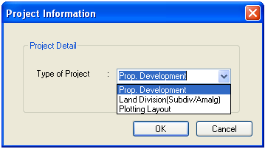
- Create AutoDCR Layers (PDCRCL): This command will create layers required for AutoDCR and as per the Project Type you have selected.
- Fix Poly (PDCRPE): Use this command once on the final drawing which will process all the polyline on the PreDCR layer and remove extra vertices found on polyline. This command can be used before verifying the drawing using Verify commands.
- Verify Drawing: This command will verify the current drawing as required by DCR specifications.
a) Verify Close Entities (PDCRVD): Verify that LWPOLYLINE entities on the selected layers are closed and contain one text .
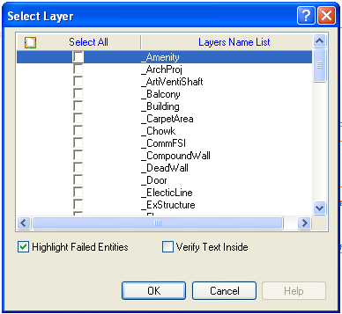
b) Verify All drawing (PDCRVT): Use this command to verify the layout and building level objects in the current drawing plan.
Major checks are as follows:
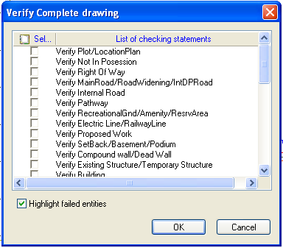
In the "Verify All Drawing Dialog" you can select the layout or building objects to be checked. Then to view the result press OK button. PreDCR will start checking all corresponding objects in the currently open drawing and then display the status as OK or list of failed objects in the dialog as shown in Figure. Failed Object Information.
- Check if these entities are drawn as closed LWPOLYLINE.
- Name text is given to all objects.
- Entities are placed exactly inside their parent objects (container).
- Naming conventions are followed properly.
c) Objection List (PDCROLST): This command gives the list of all minimum required entities which are not there in your drawing. If all required entities found then it gives a message that “minimum required entities are present in drawing”.
5. Mark: Marking adds some extra meaning in entity. Following commands are provided to mark different entities as per requirement.
  - Mark->Stair Case-> No Of Flights (PDCRSC3F): Mark staircase which having a 3 or 4 flights.
  - Mark->Stair Case->Fire Escape Staircase (PDCRSFES): Mark staircase as a Fire Escape Staircase.
Mark->Stair Case-> Fab /Spiral Staircase (PDCRSCFAB): Mark line inside staircase as a Fabricated or spiral staircase.
Mark-> Escalators (PDCRSCES): Mark Escalators which is on Staircase layer.
3. Mark->Stair Case Landing--> Intermediate Landing (PDCRMIL): Mark line inside staircase as intermediate Landing.
Mark->Stair Case Landing->Flight Width (PDCRMFW): Mark line inside staircase as Flight Width.
Mark->Stair Case Landing->Floor Landing (PDCRMFL): Mark line inside staircase as Floor Landing.
  - Mark->Passage->Covered Passage->Free from FSI OR Taken in FSI (PDCRPOCP): Mark passage as a covered passage & it is taken in FSI or Free from FSI.
Mark->Passage-> Open Corridor (PDCRPSUP): Mark passage as a Open Corridor.
Mark->Passage->Normal (PDCRPSUP): Mark passage as a Normal.
Mark->FSI->Road Widening (PDCRCONES): Mark Residential or Commercial FSI as Road widening areas FSI.
Mark->FSI-> TDR (PDCRCONES): Mark Residential or Commercial FSI as TDR.
Mark->FSI-> Existing FSI (PDCRCONES): Mark Residential or Commercial FSI as Existing FSI.
Mark->FSI->Normal (Default) (PDCRUMFSI): Mark Residential or Commercial FSI as Normal FSI.
  - Mark->Carpet Area->Splitted Tenement (PDCRMSPLTT): Mark Carpet Area as Splitted tenement.
Mark->Carpet Area->Slum Development->Sale OR Rehab (PDCRUMFSI): Mark Residential or Commercial FSI as Slum Development & Mark Carpet Area for Sale or Rehabitation.
Mark->Carpet Area-> Normal (Default) (PDCRUMFSI): Mark Residential or Commercial Carpet Area as Normal Carpet Area.
  - Mark->Balcony->Enclosed Balcony (PDCRMENCBL): Mark Balcony as enclosed balcony.
Mark->Balcony->Unmark (Default) (PDCRUMENCBL): Unmark the marked balcony.

  - Mark->Projection-- >
Mark->Projection->F.Bed (PDCRMBPROJ): Mark Projection as Flower Bed.
Mark->Projection->C.B. (PDCRMBPROJ): Mark Projection as Cubourd.
Mark->Projection->Chhajja/Cornice/Whether shade (PDCRMCJPROJ): Mark Projection as Chhajja/Cornice/Whether shade.
Mark->Projection->Canopy (PDCRMCBPROJ): Mark Projection as Canopy.
Mark->Projection->Loft (PDCRMLPROJ): Mark Projection as Loft in floor plan as well as in section .
Mark->Projection->Porch (PDCRMCPROJ): Mark Projection as Canopy.
Mark->Projection->Verandah (PDCRMVPROJ): Mark Projection as Varandah.
Mark->Projection->Garbage Shaft (PDCRMVPROJ): Mark Projection as Garbage shaft.
Mark->Projection->Refuse Chute (PDCRMVPROJ): Mark Projection as Varandah.
Mark->Projection->Ornamental Projection (PDCRMVPROJ): Mark Projection as Ornamental Projection.
Mark->Projection->Normal (Default) (PDCRUMPROJ): Mark Projection as Normal Architectural projection.

  - Mark->Road Widening->Taken In FSI (PDCRMRVIFSI): Mark When area of the road widening is taken In FSI.
Mark->Road Widening->UnMark (Default) (PDCRUMMR): Mark When area of the road widening is Not taken In FSI.
  - Mark->Existing Structure ->To be demolish (PDCRMREXWD): Mark Existing structure as to be demolished.
Mark->Existing Structure->To be retained (PDCRMRMREXWC): Mark Existing structure as to be retained.
  - Mark->SubStructure->Electric Meter Room (PDCRMER ): Mark Sub Structure as an electric meter room.
Mark->SubStructure->Electric Sub-station (PDCRMTRAN): Mark Sub Structure as an Electric Sub-station.
Mark->SubStructure->Watchman cabin (PDCRMWMC): Mark Sub Structure as a Watchman cabin.
Mark->SubStructure->Society Office (PDCRMOR): Mark Sub Structure as a Society office.
Mark->SubStructure->Servant Quarter (PDCRMSQ): Mark Sub Structure as a servant quarter.
Mark->SubStructure->Sanitary Block (PDCRMSB): Mark Sub Structure as a sanitary block.
Mark->SubStructure ->Covered Garage (PDCRMGRJ): Mark Sub Structure as a covered garage when garage is covered.
Mark->SubStructure ->Open Garage (PDCRMGRJ): Mark Sub Structure as a Open garage when garage is not covered.
Mark->SubStructure -> Rain Water Harvesing (PDCRMRWH): Mark Sub Structure as a Rain Water Harvesting..
Mark->SubStructure ->A. C. Plant Room (PDCRMACR): Mark Sub Structure as a A.C. Plant Room.
Mark->SubStructure ->AHU (PDCRMACR): Mark Sub Structure as AHU to Air handling unit .
Mark->SubStructure ->Swimming Pool (PDCRMSWP): Mark Sub Structure as a Swimming Pool.
Mark->SubStructure ->Septik Tank / Soak pit (PDCRMSPT): Mark Sub Structure as a Septik Tank.
Mark->SubStructure ->Pump House (PDCRMPR): Mark Sub Structure as a Pump House
Mark->SubStructure ->Effluent Treatment Plant (PDCRMETP): Mark Sub Structure as a Effluent Treatment Plant.
Mark->SubStructure ->Dish Antenna Room (PDCRMDA): Mark Sub Structure as a Dish Antenna Room.
Mark->SubStructure ->Well (PDCRMWELL): Mark Sub Structure as a Well.
Mark->SubStructure ->Telephone Installation Room (PDCRMTRM): Mark Sub Structure as a Telephone room.
Mark->SubStructure ->Entrance Gate (PDCRMEG): Mark Sub Structure as a Entrance Gate.
Mark->SubStructure ->Fitness Center (PDCRMCSS): Mark Sub Structure as a Fitness Center.
Mark->SubStructure ->Suction Tank (PDCRMWB): Mark Sub Structure as a Suction Tank.
Mark->SubStructure ->Pavilion (PDCRMOCP): Mark Sub Structure as a Pavilion.
Mark->SubStructure ->Gymnasium (PDCRMTRM): Mark Sub Structure as a Gymnasium.
Mark->SubStructure ->Club-House (PDCRMES): Mark Sub Structure as a Club-House.
Mark->SubStructure ->Dust Bin (PDCRMES): Mark Sub Structure as a Dust Bin.
Mark->SubStructure ->Milk Booth (PDCRMES): Mark Sub Structure as a Milk Booth.
Mark->SubStructure ->Telephone Booth (PDCRMES): Mark Sub Structure as a Telephone Booth.
Mark->SubStructure ->Letter Box (PDCRMES): Mark Sub Structure as a Letter Box.
Mark->SubStructure ->Solar Water heater (PDCRMES): Mark Sub Structure as a Solar Water Heater.
  - Mark->Margin (PDCRMRGN): Use this command to define or mark the front, sides and rear margins of the plot. .
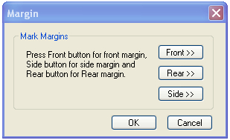
6. Insert
  - Insert->Parking-> Car L (2.5x5.5) (PDCRICP) -> Use this command to insert car-parking poly of size 2.5m.X5.5m. at selected point.
Insert-> Parking->Car S (2.3x4.5) (PDCRICP) -> Use this command to insert car-parking poly of size 2.3m.X5.5m. at selected point.
  - Insert-> Parking-> Scooter (PDCRISP) ->Use this command to insert Scooter parking poly at selected point.
  - Insert-> Parking-> Cycle (PDCRICY) ->Use this command to insert Cycle parking poly at selected point.
4. Insert->Parking->Visitors Parking->Car (PDCRIVP) -> Use this command to insert visitor car parking poly (2.3x4.5) at selected point
6. Insert->Parking-> Loading/Unloading(PDCRIVP) -> Use this command to insert Loading/Unloading parking poly at selected point
7. Insert->Door (PDCRIDRNAM): Use this command to insert door poly at selected point and with specified size given by user. As soon as you use this command the following Dialog appears.
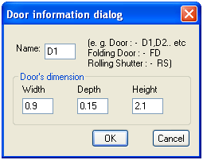
8. Insert->Window (PDCRIWNDNAM): Use this command to insert window poly at selected point and with specified size given by user.
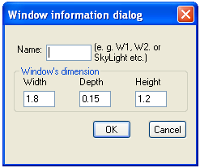
9. Insert->Sanitation Text (PDCRIWC): Use this command to insert sanitation text at selected point. Ex. Water closet , Urinal , Wash basin etc………. which is drawn on “_Sanitation” layer, then insert text by using sanitation text marking from insert menu.
10. . Insert->Direction Reference Circle (PDCRIWC): Use this command to insert direction reference circle. Insert these circles in all the floor plans as well as in proposed work at the same & common place (e.g. Lift or Stair) of all the floors.
11. Insert->Tree (PDCRIWC): Use this command to insert tree.
7. Assign Name: - There are few naming conventions required by AutoDCR, for which PreDCR provides the following tools:
    - Assign Name->Building and proposed works (PDCRBLDPWNL): Use this command to give name for building poly and its associated proposed works.
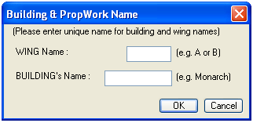
    - Assign Name->Tank (PDCRTNKNAM): Use this command to give name for Tank poly and its corresponding tanks.
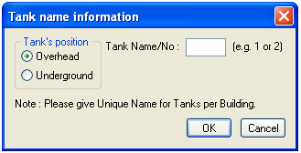
Fill in the dialog and select the tank poly drawn in plan and the same drawn in section
    - Assign Name->Room (PDCRASRUN): Use this command to give different names for Room poly.
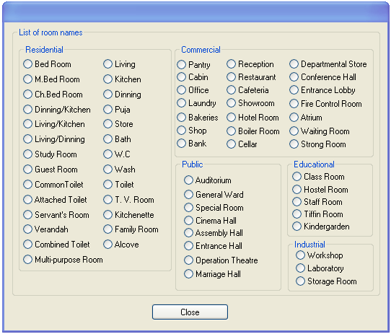

    - Assign Name->Floor Name (PDCRASFLRNAM): Use this command for assigning name to a floor poly and it’s corresponding floor in section poly in section.
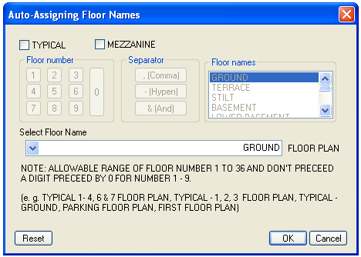
Examples
- Each and every Polyline must be drawn as LWPOLYLINE.
- Every closed polyline must contain a text inside or on the same layer.
This text will be used as the name of that polyline. As far as possible this name should be unique.
1. _Amalgamation
- Description: - Draw a continuous poly around the plots you want to amalgamate.
Amalgamation contains more than one plot amalgamated together.
All entities having amalgamation as their container entity should be uniquely present in each amalgamation.
i.e. suppose there is a road widening in the Plot then the poly of road widening should be different for each amalgamation. ( for amalgamation, draw plot 1,plot 2,plot 3 on plot layer and amalgamated plot AmalPlot 1, on amalgamation layer overlapping plot 1.)
- Verification : It Should Overlap with _PlotBoundary.
- Shortcut Command : - AMLG
- How to draw :
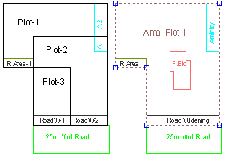

2. _Amenity

Description: - Draw Amenity space as a closed polyline which is reserve for utilities, services and conveniences.
- Basic Verifications : - It Should be Inside of PlotBoundary/ SubDivision/ Amalgamation

Shortcut Command : - AMN
- How to draw :
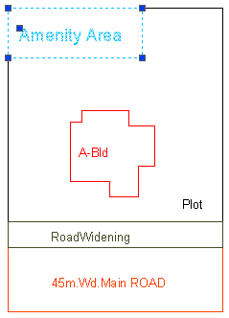

3. _ArchProj
- Description : - This layer is used to represent various Architectural Projections in your Plan. Draw a closed Polyline for Architectural Projections. And mark it using Mark->Projection from PreDCR menu, according to requirements. Canopy/porch will come in plot & other projections will come with floor plans.
- Basic Verifications : - It should be inside floor/NetPlot
- Shortcut Command: - AP.
- How to draw : -
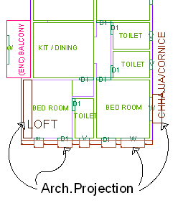

4. _VentilationShaft
- Description : - Draw ArtiVentilation shaft/duct area as a closed Polyline with Text. Inside FSIArea on _ArtiVentiShaft Layer. Only those shafts from which ventilation for habitable room is not taken should be drawn on this layer.
- Basic Verifications : - It Should be Inside of ResiFSI/ Parking/ Section/ PropWork/ Terrace/ CommFSI/ IndFSI/ SpecialUseFSI
- Shortcut Command: - AVS.
- How to draw : -
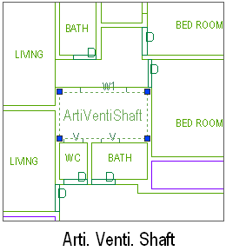

5. _Balcony
- Description : - Draw a balcony as a closed polyline which is a horizontal projection including parapet to serve as a sitting out place. Name of balcony must be inside and on _Balcony layer.
- Basic Verifications : - It Should be Inside of Floor/ NETPLOT
- Balcony can be present in :
Plot: It must overlap with PWork(if not enclosed)
Floor: It must overlap ResiFSI.
- Shortcut Command : - BL
- How to draw : -
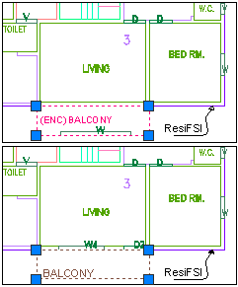

6. _ BLDGBLOCK (in layout)
- Description : -If you are submitting sub-division/amalgamation layout along with proposal for building permission also. Then you should draw sub-div/amal. layout on different drawing sheet and proposed building drawings on different drawing sheet. In this case, tentative block of building should be drawn on '_BLDGBLOCK(in layout)' just for referring the presence of building in sub-div. or amal. Plot
- Basic Verifications : - It Should be Inside of SubDivision/ Amalgamation
- Shortcut command : - BLDBLK
- How to draw : -
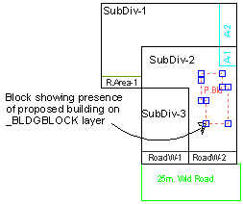

7. _Building
- Description: - Building is used to group all floor plans of the same building. Draw a closed poly enclosing all the floor plans and section of the same building on _Building layer. Note: As written above, dimension or area of this building poly has no meaning in AutoDCR. This is just an logical group of all floors of the same building. If the building plan of multiple PWorks or wings is same then building name shall be as given in table below.
Building names can be.
1 | "A(Monarch)" | PWork "A" has building plan "Monarch".
2 | "A,B(Monarch)" or "A&B(Monarch)" | Wings A, B have same building plan "Monarch".
3 | "A-C(Monarch)" | Wings A, B, C have same building plan "Monarch".
4 | "A1-A3(Monarch)" | Wings A1, A2, A3 have same building plan "Monarch".
- Basic Verifications: - Entity must contain following entities Floor & Section.
- Shortcut Command : - BLD
- How to draw: - What Building poly will have? Building poly will enclose all the floor plans in that building along.
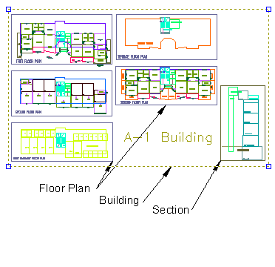

8. _Carpet Area
- Description: - Draw carpet area as a closed polyline which is a net usable floor area within a building excluding that covered by the walls or any other areas specifically exempted from floor space index computation in these regulation.
- Basic Verifications: - It should be Inside of ResiFSI/ CommFSI/ IndFSI/ SpecialUseFSI. It Should contain Room Inside it
- Shortcut command : - CPT.
- How to draw : -

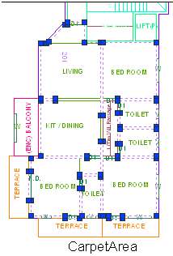

9. _Chowk
- Description : - Draw a chowk as a closed polyline which is an enclosed space permanantly open to the sky within a building at any level. From chowk we take ventilation for habitual rooms.
- Basic Verifications : - Should be Inside of : PropWork/ ResiFSI/ Parking/ Terrace/ CommFSI/ IndFSI/ Section/ SpecialUseFSI
- Shortcut Command : - CWK.
- How to draw : -
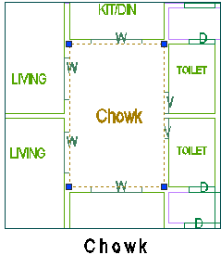

10. _CommFSI
- Description: Commercial FSI : - Draw a CommFSI as a closed polyline which is the area covered by a building on all the floors. This FSI polyline mainly used for commercial use bldg.
- Basic Verifications : - It Should be Inside of Floor. It Should contain CarpetArea Inside it
- Shortcut Command : - CMFS.
- How to draw : -
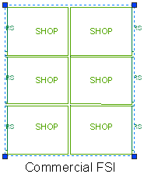

11. _CompoundWall
- Description : - Open polyline of compound wall to be drawn on proposed compound wall with text started with compound wall height. E.g. 1.5m. high Compound Wall
- Basic Verifications : -
- Shortcut Command : - CW.
- How to draw : -
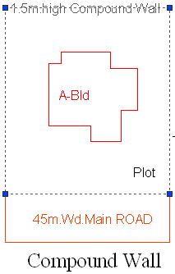

14. _Door
- Description: - Door is a closed Polyline Which is drawn on “_Door” layer. Also you can insert a particular size poly for Door using Insert->Door from PreDCR menu.
- Basic Verifications: - It should be Inside of Floor/ CarpetArea. It Should Overlap with Room/ CarpetArea/ Staircase/ Passage/ Terrace/ Balcony/ SubStructure.
- Shortcut Command: - DR.
- How to draw : -
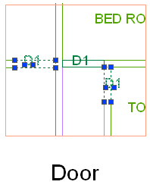

14. _ElecLine
- Description: - Electric Line: Electric line will be present in the layout plan and shall pass through plot entity as a non closed polyline.
- Name electric line shall start with its voltage capacity and text insertion point shall lie on its polyline.
For e.g. 33 KV High Tension Line
- Basic Verifications : -
- Shortcut Command: - L1.
- How to draw : -
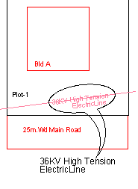

15. _ExStructure
- Description: - Draw a Exstructure as a closed polyline which is a building or structure existing authorized before the commencement of these regulation. And mark it using Mark -> Existing structure as 'To be demolished' or 'To be retained’.
- Basic Verifications: - It should be Inside of PlotBoundary.
- Shortcut Command: - EX.
- How to draw :-
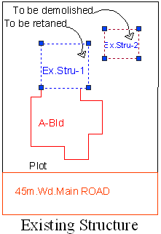

16. _Floor
- Floor: - Draw a Floor as a closed polyline to the boundary of the lower surface in a story on which one normally walk in a building and including mezzanine floor also. The floor at ground level with a direct access to a street or open space shall be called the ground floor, the floor above it shall be termed as Floor 1 with the next higher floor being termed as Floor 2 and so on upward. For giving the name of each floor use the assign named option from the PreDCR menu. Also draw each floor separately. While giving name to the typical floor then use a Typical option from Assigned name -> Floor name option from PreDCR menu bar.
- Basic Verifications: - It Should be Inside of Building. It Should contain ResiFSI/ CommFSI/ Terrace/ Parking/ IndFSI/ Staircase/ SpecialUseFSI Inside it
- Shortcut Command : - FLR
- Reference Circle: - All Floor polies must contain a circle with its center on common point for whole building on layer "_ResiFSI". Usually it can be placed inside either Common Lift or stair/Inner Chowk as their locations are common for all floors.
- Floor Name : - Floor name will be taken from text inside floor poly and on same layer.
A floor plan is automatically associated/linked by AutoDCR software with one or more floor section poly in Section plan. This is done by matching name of Floor Plan and FloorInSection so both must be same.
Typical Floor | Non-Typical
"TYPICAL" X "FLOOR PLAN"X: Floor numbers in specific format (, or & or -) | X "FLOOR PLAN"  X: Direct Floor's Name
e.g.:  TYPICAL 1,2 FLOOR PLAN  TYPICAL 1-4 FLOOR PLAN  TYPICAL 2&3 FLOOR PLAN | e.g.  GROUND FLOOR PLAN  FIRST FLOOR PLAN  SECOND FLOOR PLAN

- How to draw :-
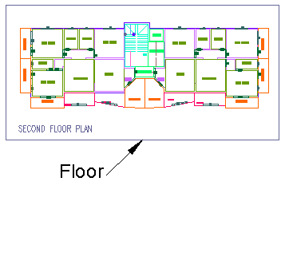

17 _FloorInSection
- Description: - Draw a Floor In Section as a closed polyline which is the height of that floor (slab top to slab top) This poly only used for checking floor height. For assigning the name of FloorInSection then used Assigned name option for PreDCR tool menu.
- Name of each floor section will be same as of floor in plan.
- For one typical floor plan multiple floor section will be there.
- For e.g. for one typical floor plan for 1-3 floors there will three sections shall be drawn with name "First Floor Plan", "Second Floor Plan" and "Third Floor Plan" respectively.
- Basic Verifications: - It should be Inside of Section.
- Shortcut Command: - SECF.
- How to draw : -
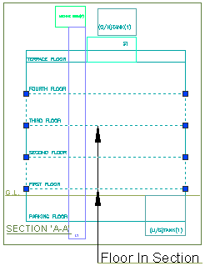`

18. _GroundLevel
- Description: - Draw the Ground level line as open polyline in section .It is used for checking a total building height from this line.
- Basic Verifications: - It Should be Inside of Section.
- Shortcut Command: - GL.
- How to draw : -
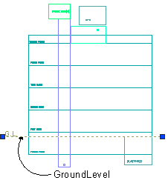

19. _IndFSI
- Description: - Draw a IndFSI as a closed polyline ( area key plan line in the submission drg) which is the area covered by all the floors. Industrial building means building or part thereof wherein products or material are fabricated , assembled or processed such as assembly plants, laboratories , power plans, refineries, gas plants, mills, dairies and factories. This polyline should be excluding balcony & terraces area.
- Basic Verifications: - It Should be Inside of Floor. It Should contain CarpetArea Inside it
- Shortcut Command: - IFSI.
- How to draw : -
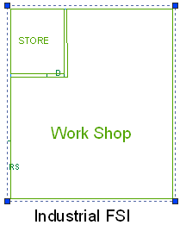

20. _IntDPRoad
- Description : - Draw existing or proposed D. P. (Development Plan) road or T. P. (Town Planning) Road when inside/intersected with plot. While giving name start text with road -width.
E.g. 15m wide D.P. Road.
- Basic Verifications : -
- Shortcut Command : - R3.
- How to draw : -
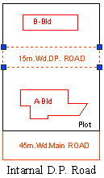

21. _IndZoneBoundary
- Description: - Draw zonal boundary of industrial zone inside plot from where required margins are to be checked.
- Basic Verifications : -
- Shortcut Command: - IZB.
- How to draw : -
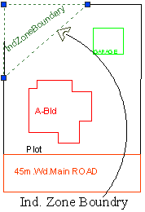

22. _InternalRoad
- Description : - Draw internal road with text specifying its width as shown in figure. And draw a center line. And type of layer of the center line must be center line (Type of the Layer).
- Basic Verifications: - It Should be Inside of MainPlot. It Should Overlap with NETPLOT/ MainPlot/ IntDPRoad/ RoadWidening/ RightOfWay/ MainRoad/ InternalRoad
- Shortcut Command: - R2.
- How to draw : -
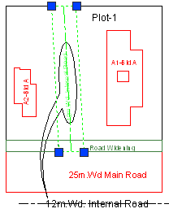

23. _Lift
- Description: - Draw a Lift as a closed polyline which is a mechanically guided car, platform or transport for persons and materials between two or more levels in a vertical or substantially vertical direction. If fire lift are provided then use the marking of “Fire lift" option from Mark -> Lift -> Fire Lift . Fire Lift means a special lift designed for the use of fire service personnel in the event of fire or other emergency.
- Basic Verifications : - It Should be Inside of CommFSI/ ResiFSI/ IndFSI/ Terrace/ Parking/ Section/ PropWork/ SpecialUseFSI
- Shortcut Command: - LFT.
- How to draw : -
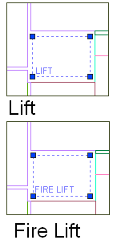

24. _LocationPlan
- Description: - Location plan if any to be drawn on this layer. This is only for reference. No verifications are done by AutoDCR for this layer so not compulsory.
- Basic Verifications : - It Should contain MainPlot Inside it
- Shortcut Command: - LCP.

25._MainRoad
- Description : - Draw a main road as a closed polyline which is abutting the plot. On the site that road is any type of road. such as any highway, street , lane, , over which the public have a right of passage or access or have passed and had access uninterruptedly for a specified period, whether existing or proposed in any schem. Road name start with its width only.
- Basic Verifications : - It Should Overlap with MainPlot/ RightOfWay
- Shortcut Command : - R1
- How to draw : -
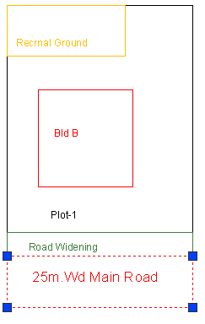

26. _MarginLine
- Description : - No need to draw Margin Line, Just use Mark Margin tool for it. This layer is not provided for users. AutoDCR uses '_MarginLine' layer for it's own internal use.

27. _Nala
- Description: - Draw Nala polygon on this layer.
- Basic Verifications : -
- Shortcut Command: - R4.
- How to draw : -
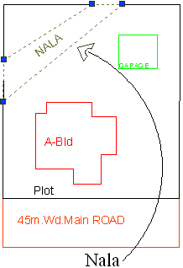

28. _NDZ
- Description: - No Development zone area if any inside plot to be drawn on this layer. And it should be drawn inside the plot with text on _NDZ layer.
- Basic Verifications: - It Should be Inside of PlotBoundary.
- Shortcut Command: - NDZ.
- How to draw : -
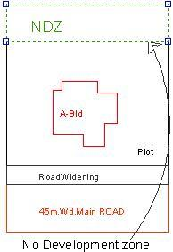

29. _NETPLOT
- Description : - No need to draw NETPLOT. This layer is not provided for users. AutoDCR uses '_NETPLOT ' layer for its own internal use.
- How to draw : -

30. _NotInPossession
- Description: - Plot area which is not in possession or which is not in proposal to be drawn as a closed polyline on this layer.
- Basic Verifications : - It should either overlap with Existing Road or RoadWidening or should be Inside and overlapping with PlotBoundary.
- Shortcut Command: - NIP.
- How to draw : -
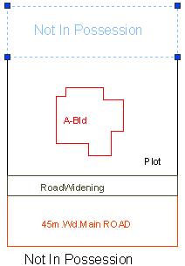

31. _Parking
- Description : - Draw a parking poly as a closed polyline which is an enclosed covered or open area sufficient in size to park vehicles. This closed polyline shall contain a text on same _Parking layer. This text is treated as name of parking. Insert the parking by using a Insert-> Parking option.
- Basic Verifications: - It Should be Inside of MainPlot/ Floor.
- Shortcut Command: - PK.
- Parking Name: - This closed polyline shall contain a text on same _Parking layer. This text is treated as name of parking.
On this layer, you can group and insert any number of parking
Parking | Name
Car Large | CP-L
Car Small | CP-S
Scooter | SC
Cycle | CY
Visitor's Parking ( Car ) | VP
- How to draw : -
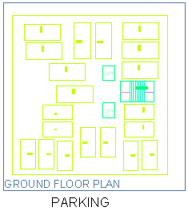

32._Passage
- Description: - A closed polyline on _Passage represents a passage. It is a common passage or circulation space including a common entrance hall. This closed polyline contain a text. This text must be on "_Passage" layer. This text is treated as name of closed polyline.
- Centre Line : - All Passage poly must contain an Open Polyline inside that closed poly representing centre line on "_Passage" Layer. But line type of center line must be 'Center line'.
- Basic Verifications: - It should be Inside of CommFSI/ ResiFSI/ Parking/ PropWork/ IndFSI/ SpecialUseFSI. It Should Overlap with CarpetArea/ Passage/ StairCase/ Lift
- Shortcut Command : - PAS
- How to draw : -
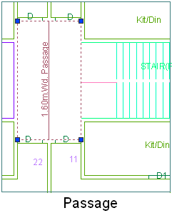

33._Pathway
- Description: - Draw pathway as a closed polyline with text specifying its width.eg.1.5 m. wide pathway.
- Basic Verifications: - It should be Inside of PlotBoundary.
- Shortcut Command: R6.
- How to draw :-
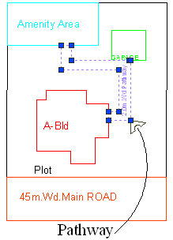

34._PlotBoundary
- Description: - Draw a Plot poly as a closed polyline which is a parcel or piece of land enclosed by definite boundaries. A Plot will contain all Proposed Works (buildings, wings), open space, Internal Roads, Parking etc. The overall Plot Entity represent a Plan, AutoDCR refers it as 'Layout Plan'. The overall Plot Entity represent a Plan, AutoDCR refer it as "Layout Plan".
- Basic Verifications: - It Should Overlap with MainRoad/ IntDPRoad/ RightOfWay. It Should contain PropWork Inside it
- Shortcut Command: PLT
- How to draw :-
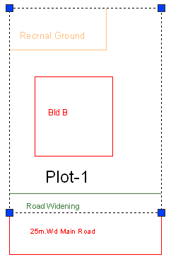

35._Podium
- Description : - Podium shall be drawn on '_Podium' layer as a closed polyline. Podium should be inside plot covering proposed works if any.
- Basic Verifications: - It should be Inside of PlotBoundary/ Floor.
- Shortcut Command: POD.
- How to draw :-
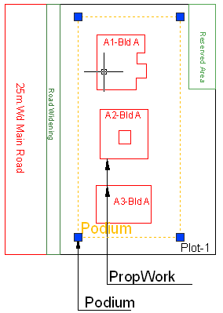

36._PropWork
- Description: - Proposed Work is a building profile/outline and shall be drawn inside plot. all detail Building plans (inside building polyline ) of all PWork( inside plot polyline) is associated/linked automatically by Auto-DCR by matching its name.
So for proper association it is required to follow specific standard as given.
XY (Z)
X is Wing name.
Y is wing number.
Z is Building name.
- For example if there are four wings A1,A2 & B1,B2 in building named "Monarch" then proposed work names shall be -
A1 (Monarch), A2 (Monarch)
B1 (Monarch), B2 (Monarch)
- Reference Circle: All PWork poly must contain two circles (of any size) with its center on common point for whole building. First on layer of any FSI and second on Layer “_Floor”. These reference circles to be inserted from PreDCR -> insert-->Direction ref circles at the same location in all the floors as well as pwork in plot. Usually they can be placed inside either Common Lift or Stair/Inner Chowk (because generally their location is same on all floors). Reference circles are used by the software for overlapping all floor plans.
- Basic Verifications: - It should be Inside of NETPLOT/ MainPlot.
- Shortcut Command: PW.
- How to draw :-
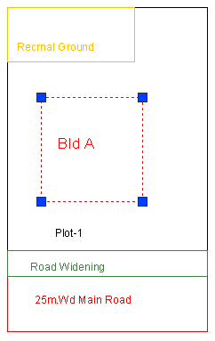

37._RailLine
- Description: - Railway line shall be drawn as a non closed polyline with some text indicating gauge of rail line over it.
- Basic Verifications : -
- Shortcut Command: - L2.
- How to draw : -
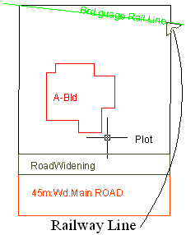

38._Ramp
- Description : - Draw a Ramp poly as a closed polyline in floor plans and/or plot and section. Naming convention for ramp is "---m. long and ---m. high ramp-1". give unique name to each ramp.
- Basic Verifications: - It should be Inside of MainPlot/ Floor. It Should Overlap with PropWork/ Podium
- Shortcut Command: - RP.
- How to draw : -
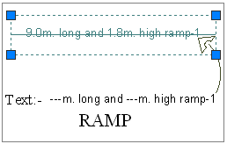

39. _RecreationalGnd
- Description : - Draw recreational ground / Open space as closed polyline reserved as recreational space on this layer. With text on same layer.
- Basic Verifications: - It should be Inside of NETPLOT/ PlotBoundary /Amalgamation / Subdivision.
- Shortcut Command: - OPS.
- How to draw : -
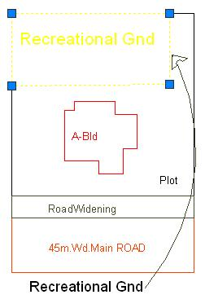

40. _RefugeArea
- Description : - Refuse area to be drawn in plan as a closed polyline with text on this layer. Overlapped with FSI layer but outside the FSI poly.
- Basic Verifications: - It should be Inside of Floor.
- Shortcut Command: - RFG.
- How to draw : -
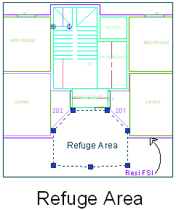

41. _ReservArea
- Description: - Reserved area ( Reservation area in Development plan) shall be drawn on this layer if present in proposal. This can be any area reserved for/by Authority for future.
- Basic Verifications: - It should either overlap with MainRoad InternalDPRoad RightOfWay or should be Inside and overlapping with Plot Amalgamation SubDivision.
- Shortcut Command:- RSA.
- How to draw :-
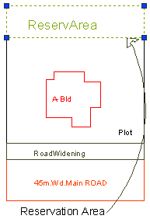

42._ResiFSI
- Description : - Draw a ResiFSI as a closed polyline which is the area covered by a building on all the floors. This FSI polyline only used for residential use building or floor. ResiFSI poly must be inside Floor poly.
- Basic Verifications: - It should be Inside of Floor. It Should contain CarpetArea Inside it
- Shortcut Command : - MFS
- How to draw : -
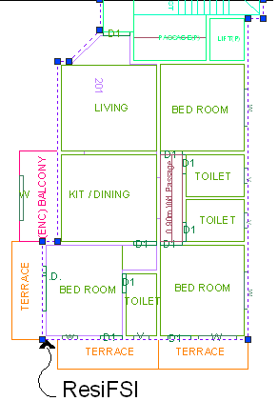

43. _RightOfWay
- Description: - Draw a closed polyline on “_RightOfWay” to represent a Right Of way and text inside it representing its width. Layer should be inside or intersecting with Plot poly.
- Basic Verifications : - It Should contain CarpetArea Inside it
- Shortcut Command: - ROW.
- How to draw : -
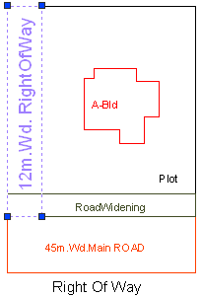

44. _RoadWidening
- Description: - Draw a road widening polyline as a closed polyline which the plot area is going to the road, that area should be drawn on this layer. It should be inside the plot polyline.
- Basic Verifications: - It should be Inside of MainPlot. It Should Overlap with MainRoad/ IntDPRoad.
- Shortcut Command: - R5.
- How to draw : -
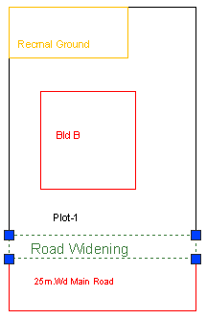

45. _Room
- Description : - A closed polyline on _Room layer represents a room. This closed polyline contain a text. This text must be on _Room layer. Room to be marked by assigning them names using Assign Name-> room option from PreDCR menu.
- Basic Verifications: - It Should be Inside of CarpetArea.
- Shortcut Command: - RU.
- How to draw : -
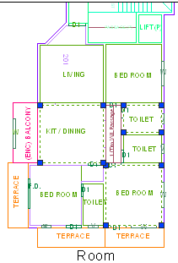

46._Sanitation
- Description : - Draw any sanitation entities on this layer. (E.g. Water closet, Kitchen sink etc..) Mark those entities by using PreDCR -> Insert -> Sanitation.
- Basic Verifications : -
- Shortcut Command: - SND.
- How to draw : -

47._Section
- Description: - Draw a Section polyline as a closed poly of section boundary which contain all floors with stair cabin, Lift machine room, water tanks etc. as shown in the figure. Also write the name as "Section" in this section poly.
- In this closed poly of section draw sections of all floors with stair cabin, inner Chowk, Lift machine room, Ventilation shaft, water tanks etc. as shown in the figure.
- Also write the name as "Section" in this section poly.
- This section poly will present inside the building poly.
- Basic Verifications: - It should be Inside of Building.
- Shortcut Command: - SEC.
- How to draw : -
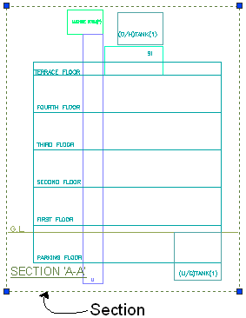

48. _Sewageline
- Description: - Drain/Sewage Line: - Sewage line shall be drawn as a open polyline on this layer.
- Basic Verifications : -
- Shortcut Command: - L5.
- How to draw : -
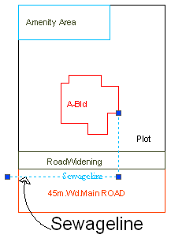

49. _SitePlan
- Description : - Site plan if any to be drawn on this layer. This is only for reference. No verifications are done by AutoDCR for this layer. so not compulsory.
- Basic Verifications : -
- Shortcut Command : - STP

50. _SpecialUseFSI
- Description: - FSI ploy for all other building uses like educational, institutional etc. except ResiFSI, CommFSI & IndFSI use should be drawn on this layer.
- Basic Verifications: - It should be Inside of Floor. It Should contain CarpetArea Inside it
- Shortcut Command: - SUF.
- How to draw : -
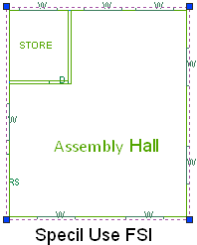

51. _StairCase
- Description : - StairCase: On this layer, Each StairCase poly shall have three lines for Flight Width, Intermediate Landing and Floor Landing on same layer. Mark these open polyline by using Mark-> Staircase option from PreDCR menu. Also draw in plan all the treads on this layer which is a open polyline.
- This closed polyline contains a text. This text must be on _Stair layer. This text is treated as name of closed polyline. On this layer, Each StairCase poly shall have three lines for Flight Width, Intermediate Landing and Floor Landing on same layer This can be mark by tool Mark > StairCase > intermediate landing etc.
- Basic Verifications : - It should be inside Floor / proposed work
- Shortcut Command: - STR.
- How to draw : -
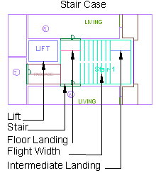

52. _ SubDivision
- Description: - In Subdivision one plot is divided into more than one Subdivision.
All entities having subdivision as their container entity should be uniquely present in all Subdivisions of a Plot i.e. suppose there is a road widening in the Plot then the poly of road widening should be different for each Subdivision (subdivided plot).
Ex. Here Plot 1 is divided into three Subdivisions. And also the Road Widening is divided into RoadW 1 and RoadW 2 for each Subdivision.
(For subdivision, draw plot 1 on plot layer and subdivided plots like SubDiv 1, SubDiv 2 & SubDiv 3 on sub-division layer overlapping plot 1.)
- Basic Verifications : -
- Shortcut Command : - SBD
- How to draw : -
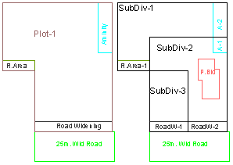

53. _SubStructure
- Description: - Draw various substructures on "_SubStructure" layer as a closed polyline. And mark it according to the requirement as Mark -> Substructure -> Society Office, from PreDCR menu. Sub-structures can be drawn inside plot or in floor plans.
- Basic Verifications: - It should be Inside of NETPLOT/ Floor.
- Shortcut Command: - SSTR.
- How to draw : -
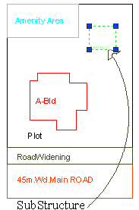

54. _SurrenderToCorp
- Description: - In case of accommodation reservation, the plot area or FSI to be surrendered to NMC is to be drawn on This layer. With text inside it.
- Basic Verifications : - It Should be Inside of PlotBoundary/ Floor
- Shortcut Command: - STC.
- How to draw : -
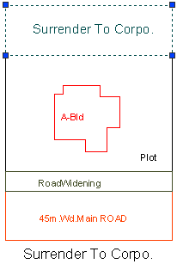

55. _Tank
- Description : - A closed polyline on _Tank layer represents a water tank. Under Ground tank can be drawn in Floor or Layout plan. If it is drawn in Floor plan then it should be at bottom of GROUND FLOOR. Overhead tank can be drawn in TERRACE FLOOR. Tank should be drawn as per internal size or dimensions. Both the tank also draw in section also.
- Tank Name: - This closed polyline contain a text and must be in given format. This can also be done by tool Assign Name>Tank
Tank Name+ Type +Capacity
Tank Type | Text
Overhead water tank | (O/H)
Underground water tank | (U/G)
For e.g.
TANK-1 (O/H)
TANK-2 (U/G)
- Under Ground tank can be drawn in Floor or Layout plan. If it is drawn in Floor plan then it should be at bottom of GROUND FLOOR.
- Overhead tank can be drawn in TERRACE FLOOR. Usually it is drawn on StairCase poly in TERRACE FLOOR.
- Basic Verifications: - It should be Inside of NETPLOT/ Floor/ Section.
- Shortcut Command: - TNK.
- How to draw : -
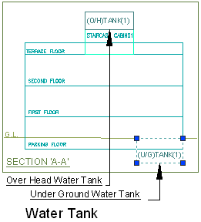

56. _TempStructure
- Description: - Area for temporary structures to be drawn as closed polyline with text on this layer.
- Basic Verifications : -It Should be Inside of PlotBoundary
- Shortcut Command: - TMPS.
- How to draw : -
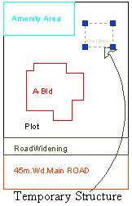

57. _Terrace
- Description: - Draw a Terrace as a closed polyline on _Terrace layer which is including parapet wall.
- Terrace can be present in:
Plot: It must overlap with PWork
Floor: It must be outside the ResiFSI.
- Basic Verifications : - It Should be Inside of Floor/ NETPLOT
- Shortcut Command: - TER.
- How to draw : -
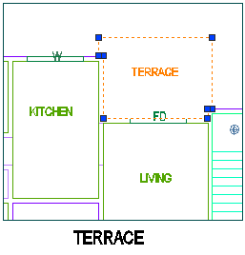

58. _UpperSetBack
- Description: - Draw a closed polyline in plan as well as in proposed work which having setbacks.
- Basic Verifications : -It Should be Inside of PropWork/ Floor
- Shortcut Command: - USB.
- How to draw : -
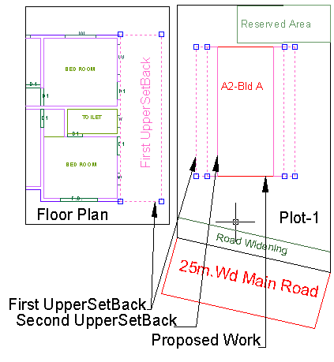

59. _Void
- Description : - If the space is not Chowk then it can be void. All ducts (where ventilation is not taken) and double height rooms can be drawn in void layer.
- Basic Verifications : -It Should be Inside of CommFSI/ ResiFSI/ IndFSI/ SpecialUseFSI/ PropWork/ Terrace/ Parking
- Shortcut Command: - VD.
- How to draw : -
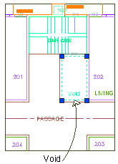
60._WaterLine
- Description: - Draw a Water line as a open polyline to show Water supply.
- Shortcut Command: - WL.
- How to draw : -
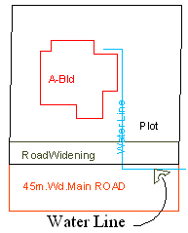

61. _Window
- Description: - Window is a closed Polyline Which is drawn on "_Window" layer. Also you can insert a particular size poly for Window using Insert->Window from PreDCR menu.
- Basic Verifications : - It Should be Inside of Floor/ Balcony/ CommFSI/ ResiFSI/ IndFSI/ SpecialUseFSI and It Should Overlap with Room/ CarpetArea/ Balcony/ StairCase/ Passage
- Shortcut Command: - WND.
- How to draw : -
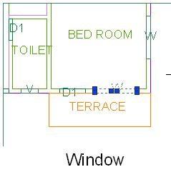

Tools
- All/Remover Tool Tip ( PDCRTOOLTIP ):
This command will activate the tool tips for PreDCR layers.
- Show Only DCR Layers:
  - All PreDCR layers (PDCRSPL):
This command will turn off all the layers in the drawing except PreDCR layers.
  - Building level layer (PDCRSBL):
This command will turn on all the building plan level layers in the drawing.
  - Layout level layer (PDCRSLL):This command will turn on all the Layout plan level layers in the drawing.
- Show Only DCR Layers (PDCRSDL):
This command will turn off all the layers in the drawing except DCR layers.
- Show Other Layers (PDCRSOL):
This command will turn off all the DCR and PreDCR layers in the drawing.

- Show All layers (PDCRSAL);
This command will turn on all layers in the drawing.

- Calculate Total Area (PDCRCTA):
This command will compute the total area of all selected closed polygons.
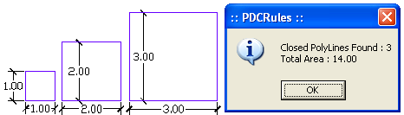

- Calculate Deducted Area (PDCRCDA):
This command will compute the area of closed polygon after deducting closed polygons found inside.
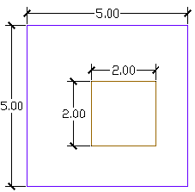 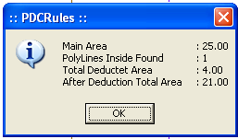
- Get All Inside Poly (PDCRFIP):
This command will highlight all polygons, which found exactly inside selected polygon under test.
- Get All Overlapping Poly (PDCRGOP):
This command will highlight all polygons, which are overlapping with selected polygon under test.
- Get All Intersecting Poly (PDCRGIP):
This command will highlight all polygons, which are intersecting with selected polygon under test.
- Find Open Entities (PDCRFNDO): Highlight open entities on PreDCR layers.

- Find Closed Entities (PDCRFNDC): Highlight closed entities on PreDCR layer.

- Shortest distance (PDCRFSD):
This command will find the shortest distance between two entities.

- Spelling check (_spell): This tool is used for spelling checking.

- Find Object (PDCRFOBJ): This command zoom & highlight object of a given handle.

- Set Default ACAD Version ( PDCRSDA ): This command will help to remove the default option from the first dialog box.

